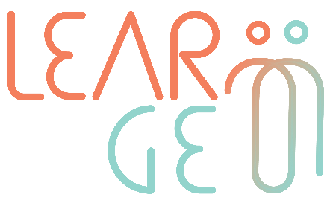

02: Training package for employees trained to become mentors
Developer: Institute of Development, Cyprus
Module 4– Digital tools for mentoring
Learning unit 8 – Basic of e-mentoring
Handout 1: Interactive platforms and ideas for e-mentoring
Activity 1: Digital tools for e-mentoring

Interactive platforms and ideas for e-mentoring
- List of Online Mentoring Platforms with relevant information and contact details:
https://www.growthmentor.com/blog/online-mentoring-platforms-software/

- Online Youth Mentoring Programmes and Support: https://youthassistingyouth.com/activities/virtual-programs/

- Kahoot is a popular platform you can use for interactive games and timed polls for competing with others: https://kahoot.it/

- Dialup is an app that connects people into calls for various subjects (like arts, books, movies, emotional support in particular topics). To use you can download the app, register and choose the type of chat you want to participate in and the chat will connect you with likeminded people.

- Skype together on a video call. Skype also has the function “share screen” so you will be able to show information and discussions on those topics.

- Movie/Book club. Set as your task to watch a specific movie (doesn’t have to be together). Meet at some point during the week after watching that movie and talk about the movie, the characters, what would you have done in their situation? Any valuable information and examples you could apply in your life/work?

- Moodboard. Create a moodboard (what makes you happy, what is important to you, goals, aspirations) and share with each other. This will help you to clarify your goals and aspirations and will give the mentor more insights on how to support you in this journey.

- Dining Together. Connect online through a video call and dine together virtually.

- Virtual Museum Tours. Attend tours virtually, this could be virtual tours of museums which you can find online. Visit famous landmarks and explore new interesting places. Mentors could also assign to the mentees challenges and/or questions to answer.

- Exchange Handwritten Letters. This is a great way to express your emotions and it evokes positive feelings and a sense of appreciation for taking the time to go through the whole ritual of preparing and sending a handwritten letter.

