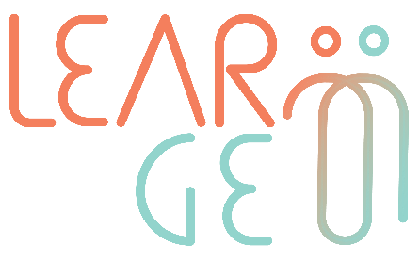

02: Training package for employees trained to become mentors

Developer: Mindshift Talent Advisory, Portugal
Module 3– Mentoring scenarios for role-play practice
Handout 3: My first mentoring session

I. Mentoring agreement

(Only one page)

II. Mentoring session log

(Only one page)

