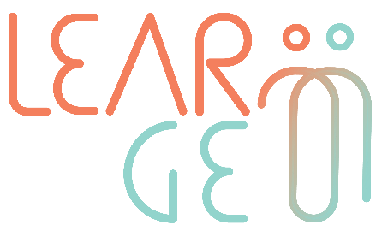

02: Training package for employees trained to become mentors

Developer: Mindshift Talent Advisory, Portugal
Module 3– Mentoring scenarios for role-play practice
Handout 2: Mentor preparation phase checklist

Getting started with mentoring

Mentor preparation phase checklist
Steps I need to take before starting | Resources I need to have in hand
Example  ☒ Design a mentoring agreement | Example  Link to mentoring agreement templates I can adapt:
☐
☐
☐

(Add more rows if needed)

Tips to complete the checklist
- Remember that you are completing this checklist from a specific example, i.e. following what Linda and Robert need to prepare before their mentoring sessions
- Try to be specific having in mind what Linda or Robert would need to collect to prepare their first mentoring session

