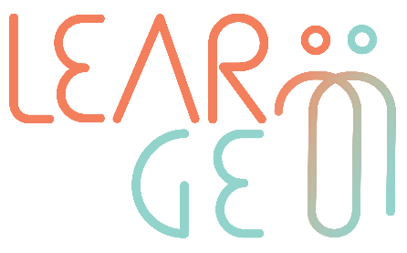

02: Training package for employees trained to become mentors

Developer: Institute of Development, Cyprus
Module 2– Competency framework for skills transfer
Handout 1: Skills of meta-position – part 1
Activity 2: Skills of meta-position

Positions Definition:
First position: Self – this is when you are standing in your own physical space. When referring to the first position, the participants should use words like “me”, “I”, and “myself” to describe and express their own feelings, perceptions and ideas. When a person is mindfully experiencing being in the first position, they are fully experiencing the process of communication from their own perspective: visual observation, listening, feeling, everything that is going on at that given moment internally and externally.
Second position: is having the capacity to comprehend and speculate another person’s perspective within the interaction (If there are more than two persons participating in the interaction-conversation, there may be multiple “second positions”). This is a temporary position, whereas the other person can observe and collect useful information in to understand the other person’s perspective.
To ensure that, the person can visualise or physically change position and take the other person’s physical stance-position in order to observe what is happening around them from that particular place. Through standing to their position, they can see, observe, hear and feel how the communication flow seems from the other person’s eyes (like “standing in their shoes” – also closely correlated with the notion of empathy). In this way, the person will briefly disassociate from their own position and perspective and understand the point of view of the other person(s).
Third position: “The observer” position, placing yourself entirely out of the communication process and dynamics will help you gather information as though you are just witnessing the communication taking place without being an active part of it. The body posture of the observer should be more relaxed and symmetrical. Through the observer’s lens, the person will have the opportunity to see, hear and experience the communication flow from the position of an interested but still neutral party. To refer to the third position, you should be using “third person” language, such as “she” and/or “he” to describe the persons who have an active role in the conversation-communication (including how they appear, how they stand, the gestures they make, their speech and their overall actions). The observer should be completely disassociated from the interaction, and in a form of a “meta” position. Through the observer viewpoint, we can gather important information regarding the balance of behaviours and perhaps useful points and pieces on how to dissolve a conflict or escalate the conversation in such manner that will conclude in an agreeable manner for all parties involved.
Fourth Position: Will be introduced to the participants, after the completion of the role of three previous positions, as an amalgam of all other three. The fourth position represents the notion of the “bigger picture”, where the person combines all the previously mentioned viewpoints in order to come closer to an impartial analysis of the situation.
In summary:
1st Position: First person, your own point of view, beliefs and assumptions, seeing the external world through your own eyes – an “I” position.
2nd Position: Being in another person’s shoes, understanding their own point of view, beliefs and assumptions, seeing the world through his or her eyes – a “you” – “the other” position.
3rd Position: The Observer, outside of the relationship – a “they” position where you get the role of an observer.
4th Position: Associated in a point of view of the “bigger picture” – the “Field” where you combine all the previously mentioned perspectives in order to come closer to an impartial analysis of the situation.

2nd Position
OTHER
1st Position
SELF

3rd Position
OBSERVER
4th Position
FIELD

This activity is based on an approach developed by Gilligan (2002) and proposes that during an interaction / conversation we must be alert, flexible and open to accept different opinions within the interaction. Moreover, Gilligan (2002) highlights that a person should be also flexible and kind with themselves and leave room for the possibility to perhaps change their mind or allow a shift in their own initial perspective.

This shift of perceptual positions is referred to as a “triple description”, since there are three different perceptual positions occurring within a typical conversation. Those perceptual positions are my own perception (first position), the other individual (second position), and the observation of the both of us (third position).

