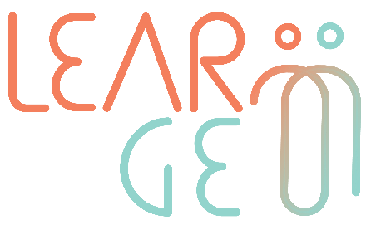

02: Training package for employees trained to become mentors
Developer: Mindshift Talent Advisory, Portugal
Module 1– Principles and techniques of mentoring and reverse mentoring
Learning unit 1: Introduction to mentoring and reverse mentoring
Handout 1: Mentor and mentee profile
Activity 2: Mentoring skills snapshot

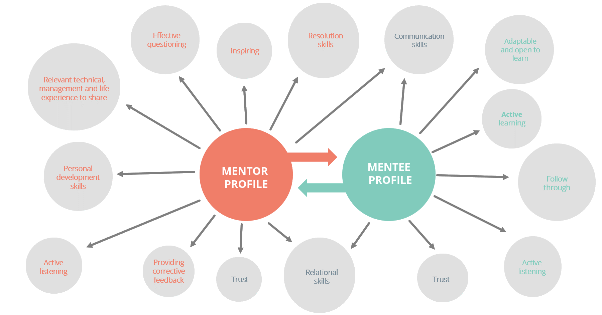

Table 1 - Skills I can explain or describe
Skill | Brief explanation
(+ add more rows if needed)

Table 2 - Skills I can’t explain or describe
Skill | Brief explanation
(+ add more rows if needed)

Table 3 – Checking my mentoring skills
Mentor profile | Mentee profile
☐ I’m able to support others developing capabilities and competences  ☐ I’m able to inspire others  ☐ I can provide corrective feedback  ☐ I can question effectively  ☐ I can manage risks  ☐ I’m able to open doors to other, when it comes to supporting them to access new job opportunities, for example.  ☐ I have relevant expertise that I can share with others  ☐ I like to learn and improve my competences  ☐ I’m eager to gain new knowledge  ☐ I’m a very supportive person and like to encourage others  ☐ I have strong communication skills  ☐ I’m able to listen actively and question effectively  ☐ I value trustful relationships | ☐ I recognize the importance of being guided  ☐ I understand the concept of active learning  ☐ I’m an active learner  ☐ I often take initiative  ☐ I can follow plans  ☐ I can establish and manage relationships  ☐ I’m able to listen actively  ☐ I value trustful relationships  ☐ I easily adapt to situations  ☐ I’m open to learn  ☐ I have good communication skills

